To celebrate the two new homes at 63 and 147 Gridley Street, Greater Bristol Homes (GBH), which originated the project as part of its commitment to improving Bristol’s housing stock, has committed an additional $5000 to further improve the neighborhood.
That money will be awarded in the form of grants of up to $500 each to Gridley Street homeowners who improve their property, specifically a part of their property facing the street. The two new homes have improved the streetscape and we’re encouraging and helping existing property owners to improve it further.
Let’s make Your Neighborhood prettier together!
Qualifying projects can be anything that improves the look of the street, for example:
- New landscaping and plantings
- Painting your house
- New fencing
- Repairing and painting your front porch
The key thing is that it must be an improvement that faces the street. The final decision on what qualifies for a grant lies with GBH. Once a grant is approved the $500 will be held by GBH until the project is fully complete at which time funds will be disbursed to the homeowner.

Here are the process and rules:
- Applications are available at www.greaterbristolhomes.org or can be mailed to you at your request. Complete the application, include supplemental information to clarify and strengthen your request.
- The application requires:
  - A full description of the project, photos and drawings are encouraged
  - A budget for the project, full cost, item-by-item, everything
  - A timeline for the completion of the project
- Applications must be completed and mailed by August 30, 2024
- Approvals will be granted on a rolling basis, first come, first served until the funds are exhausted
- Work must be completed within 180 days of grant approval
- You can do-it-yourself with family and friends or hire a licensed contractor
- You will need to show receipts for all expenditures
- Projects are not limited to $500, but each grant will only cover the first $500 of completed projects
- Projects of less than $500 also qualify but the grant is limited to cost of the project
Questions? Request an application? Contact us at info@greaterbristolhomes.org
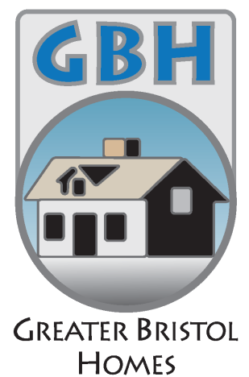
Mail completed applications to:
Greater Bristol Homes
P.O. Box 3124
Bristol, CT 06011-3124

Thanks and good luck!!

